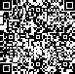[2009] 082 









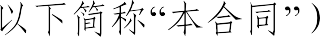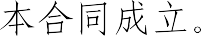

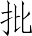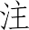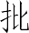

 0    30 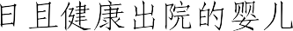 

18   

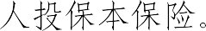



 30  

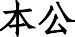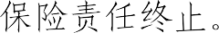

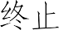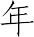

 

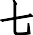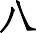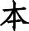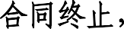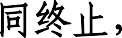

 1

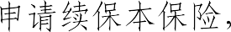



 

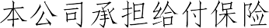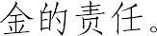



 30 







  

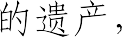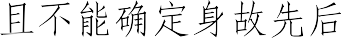

 10 



   

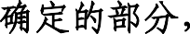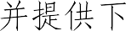

1 

2 

3  



4    

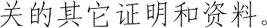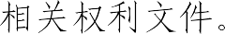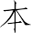

5    30  



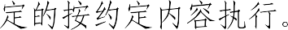

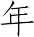

10  





  3 



 60



 2 



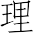

1  





2  



 



3  

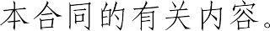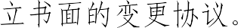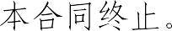

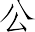

  30 



 

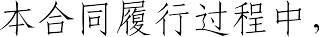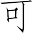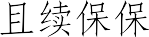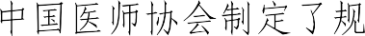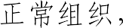

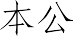

  ICD-10 



# 1

**2** 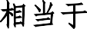 **Binet ** **A **

**3** 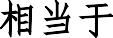 **Ann Arbor ** **I **

**4 **  

# 5 TNM T1N0M0 6



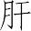





1

2

3 B 4







PET





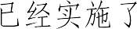



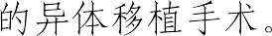



CT  MRI 



1  



2 



  180  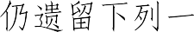



1 

2 

3    



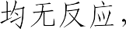  Glasgow coma scale

 5  5 



  96  

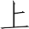



  500

 1000  2000 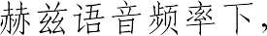 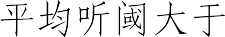 90





 **0 ** **3 ** 



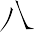

1 

2  0.02





3 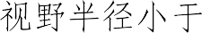 5

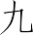



180 





 180 









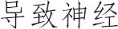

  CT 

MRI  PET 

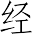

  180  

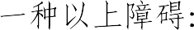

1 

2 



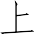

3    





20% 20%  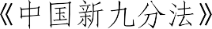 

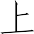

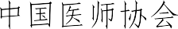



   60

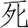



1  

1  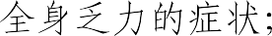



2 

3   

2   4 



1 

2  

3  

4  >2.1KPa 

5 

6 X  

7  



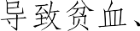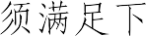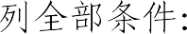

1 

2 

1 9/L

2 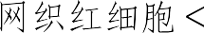 1%

3 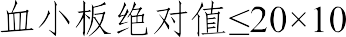9/L







 3 



1  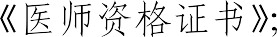

2  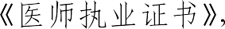 



3 

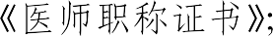

4 

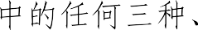

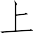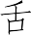

1  

2   



3  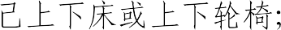



4  



5    

6   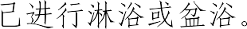



 180  

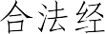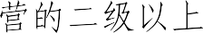

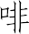

1 

2 

3 

4   

 



1 

2 

3 

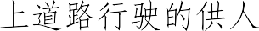

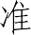

   × 1 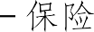

 /    1  1 



   25%



